Week Ending: | DAY: |  |  | Subject: Creative Arts
Duration: 60mins per lesson |  |  |  | Strand: Visual Arts & Performing Arts
Class: B6 | Class Size: |  |  | Sub Strand: Thinking and Exploring Ideas
Content Standard:  Demonstrate understanding of how to generate own ideas for artistic expressions on topical local/national/global issues. |  |  | Indicator:  B6.1.2.2/ B6.1.2.3 create own artworks that reflect the physical and social environments of some communities in the world |  |  | Lesson:  1 OF 1
Performance Indicator:  - Learners can creating own artworks that reflect the physical and social environments of some communities in the world |  |  |  |  | Core Competencies:  Decision Making Creativity, Innovation
Teaching/ Learning Resources |  | Photos, videos, art paper, colors and traditional art tools
References: Creative Arts Curriculum Pg. 63
DAYS | PHASE 1: STARTER | PHASE 2: MAIN | PHASE 3: REFLECTION
 | Activate the previous knowledge of the learners by making them answer questions on the previous lesson.  Engage learners to play games and sing songs to begin the lesson   | Engage learners to make a simple beadwork using materials in the local community.  Learners gather materials and tools available in their community.  Demonstrate and guide learners to make a simple beadwork.  Allow learners to practice in groups following the steps provided  Learners to discuss and compare their artworks to the artworks studied. | Use questions to review their understanding of the lesson  Ask learners to summarize what they have learnt
 | Show learners pictures of the dance for them to talk about it.  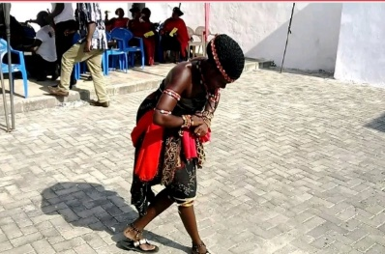 | In our last performing arts lesson, we learnt how to create our own dance moves.  Guide learners to pick a piece of music for the dance.  e.g. Adowa dance  Guide learners to determine the style and plan for the dance.  Show learners a video or pictures of the dance.  Demonstrate the dance moves to learners as they observe.  Have learners practice the moves in a formation dance | Use questions to review their understanding of the lesson  Ask learners to summarize what they have learnt

